1. Pappy
2. 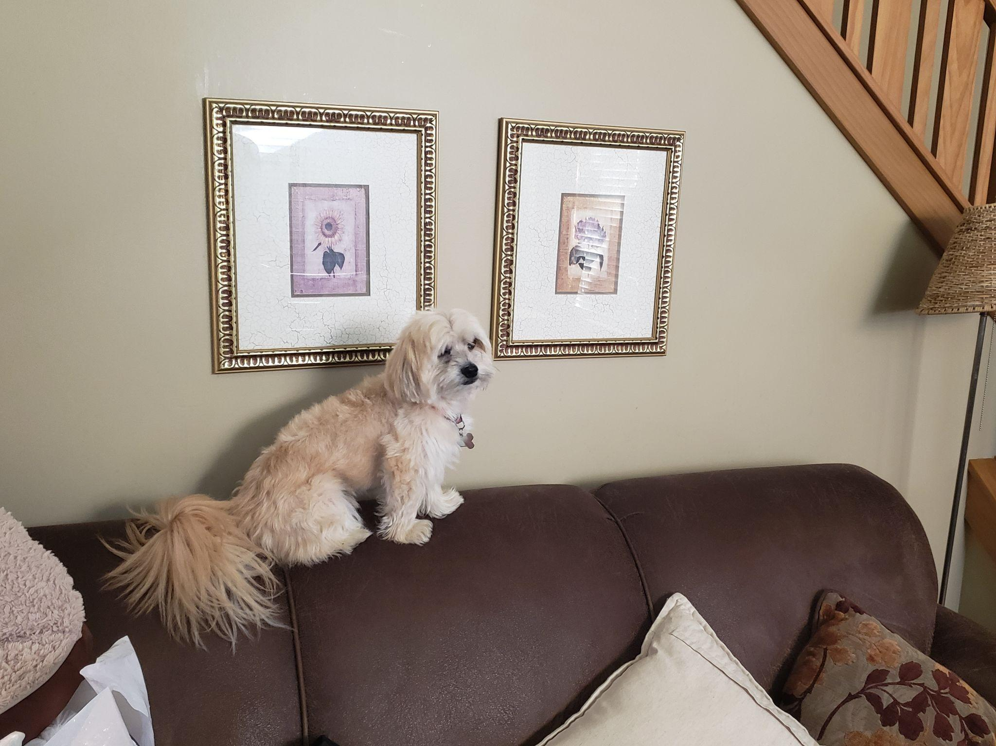
3. couch_pappy.jpg
4. Tan Morkie sitting on couch
5. Pappy is a 7 year old morkie. Most days he prefers to spend it laying around the house in his various favorite spots. Most of the time you can find him lying in his bed. He loves going with walks, but still hasn’t figured out how to approach other dogs without scaring them off. He loves his family and loves to keep intruders away even for his size.
6. He also enjoys playing with his favorite basketball. He loves pushing it around, scratching it, or even talking with it. He also loves his little stuffed animal too. Pappy also loves to be scratched and will ask you to keep scratching until he is happy.
7. **Photo Gallery – (Just write Photo Gallery)**
8. sun_pappy.jpg
9. Pappy taking in the sun on a sun chair
10. hiding_pappy.jpg
11. Pappy hiding in his favorite spot when he was younger
12. glasses_pappy.jpg
13. Pappy putting on “his glasses” to read a book
14. popsicle_pappy.jpg
15. Pappy enjoying a homemade popsicle on a hot summer day
16. **Likes**
17. Taking naps with his paws in the air
18. Getting scratches or belly rubs
19. Any kind of dog treats
20. Brian Cereceres